SWAP report Kyrgyzstan 2024: 6 indicators reports
UNCT SWAP indicator and criteria | Suggested report:
2.3: UNSDCF Monitoring and Evaluation Measures Progress Against Planned Gender Equality  - Meets TWO of the following: a) UNSDCF Results Framework data for gender sensitive indicators gathered as planned. b) UNSDCF monitoring/reporting/ reviews/ evaluations assess progress against gender-specific results. c) The MEL Group or equivalent has received technical training on gender sensitive M&E at least once during the current UNSDCF cycle. | - Met  Gender sensitive indicators under UNSDCF results framework gathered as planned with all participating agencies providing their inputs into the Annual reporting and Joint Work planning process throughput the planning and reporting process.  This was done within the working processes on UNSDCF Results Groups consultations, feeding to the revision of 2023-2024 report and planning exercise culminated with the Joint Government-UN Strategic Coordination Committee’s Meeting that took place on the 28th of March 2024. Currently the UNCT is undertaking a review of the 2023-2024 JWP implementation revising UNSCF gender specific results and indicators to inform the planning process for 2025-2026.  - RGs spreadsheets reporting on gender indicators  - UNSDCF indictors with targets achieved for 2023-2024  - MET  The UNCT is in the second year of its implementation planned for the 2023-2027. Since its operationalization through the biannual Joint Workplan UNSDCF for 2023-2024, joint monitoring and reporting to assess the 17 out of 18 UNSDCF gender specific results is taking place in accordance with the reporting and planning process roadmap and engaging national partners from National Gender Machinery and GEWE CSOs  - Presentation made at the Joint Government-UN Strategic Coordination Committee’s Meeting on 28th of March  - Roadmap for the JWPs planning and reporting process  - UNSDCF gender specific results overview
3.1: UNCT Collaborates and Engages with Government on Gender Equality and the Empowerment of Women  - Meets TWO of the following: a) The UNCT has collaborated with at least two government agencies/entities/institutions on a joint initiative that fosters gender equality within the current UNSDCF cycle. b) The National Women’s Machinery or equivalent entity participates in UNSDCF consultations: CCA, Cooperation Framework design, implementation, M&E. c) The UNCT has made at least one contribution to substantively strengthen Government participation and engagement in gender related SDGs localization and/or implementation. | - Met:  - Through the implementation of the joint “16 days of Activism to end violence against women” campaign with its whole-of-a-state approach and joint launch organized with the key stakeholders, including the Cabinet of Ministers, CSOs, international organizations, the private sector, the media and academia.  The annual campaign "16 Days of Activism to End Violence against Women" was launched in Kyrgyzstan. | United Nations in Kyrgyz Republic  Prior to this event, a dedicated meeting of the Gender Council under the Head of the Cabinet of Ministers took place to launch the campaign at the Government level:  Глава кабмина поручил пересмотреть госпрограммы и мероприятия по предотвращению семейного насилия  This collaboration is implemented within the UNSDCF result group 4: Accountable and inclusive institutions and civil society fostering peace & social cohesion  - The UNCT (UNDP, UN Women and UNRCCA) has been working with Women Parliamentarians within the Central Asian Women Leadership Caucus to facilitate regional dialogue on gaps and challenges to the progress in implementation of the 1325 Security Council Resolution. Under the leadership of Kyrgyzstan in 2024, UN Country Team supported the Parliament in conceptualizing and facilitating a series of dialogues including (i) The Role of Women in the Economy of Central Asian Countries: Leadership for Advancing Digital, Social and Environmental Innovations (RG2 and 4), (ii) The Role of Women in Strengthening Peace and Security in the Central Asian Region and Afghanistan (RG4), addressing the issues climate change and water diplomacy, and (iii) Central Asian EXPO as an approach to foster regional cooperation aimed at expanding inclusive economic opportunities for women innovators in Central Asian countries (RG2).  CAWLC report  - MET  The National Women’s Machinery represented by the Ministry of Labor, Social Security and Migration (MLSSM) and participates in the UNSDCF national consultations on JWP implementation, as one of the key national partners engaged. The minister, deputy minister and/or the head of the Department in charge of National Gender policy implementation participates at different RGs national consultations organized (4 of them) and them at the Strategic Coordination Committee level held at the Cabinet of Ministers:  - Presentation made by the Co-chairs of RGs during the Joint Government-UN Strategic Coordination Committee held on the 28th of March 2024  - LOPs of the National consultations and Strategic Coordination committee  - NOT MET  The UNCT has made AT LEAST ONE contribution to substantively strengthen Government participation and engagement in gender-related SDGs localization and/or implementation:  On 16 March 2023, over 50 representatives from Government, Civil Society, and Development Partner organizations learned about the SDGs progress and gender data use for policy and decision-making during the launch of the publication “SDGs and Gender Equality”. This publication was released by the National Statistical Committee with technical support from UN Women and other members of the UNCT, and included 4 Gender Snapshots on the following topics: 1. Unpaid care & domestic work, 2. VAW in Kyrgyzstan, 3. Women’s participation at all levels of decision-making and 4. Women’s economic activity in Kyrgyzstan. Though there is no evidence of substantive strengthening of the Government’s engagement in gender related SDGs localization and/or implementation, there is an opportunity to strengthen it in 2025 through a planned VNR process.
3.1.UNCT COLLABORATES AND ENGAGES WITH WOMEN’S GENDER EQUALITY CSOs  Meets two of the following: a) The UNCT has collaborated with GEWE CSO and women’s rights advocates on at least two joint initiatives that foster gender equality and empowerment of women within the current UNSDCF cycle. b) GEWE CSO participates in UNSDCF consultations: CCA, Cooperation Framework design, implementation, M&E. c) The UNCT has made at least one contribution to substantively strengthen GEWE CSO participation and engagement in gender related SDGs localization and/or implementation. | - MET:  - MET: The UNCT actively collaborates with GEWE CSOs and women rights advocates on a number of national and international processes and programmes that guide the UNSDCF 2023-2027 implementation:  - Women CSOs and women rights advocates participated actively throughout the process of the national 30 years review and implementation of the BPfA report led under the leadership of the National Gender Machinery and with technical support from UNCT (UN Women, UNDP and UNICEF): List of participants of the national consultations organized and presentations made  Список для регистрации_B+30.docx - Google Docs  2. UNCT collaborated with the Women CSOs while developing the first ever State Program on Women’s Leadership symbolizing a steadfast commitment of the Government to address the formidable barriers impeding women from attaining senior roles in the executive sphere. Women CSOs were engaged into a number of consultations organized for its development and finalization, including the presentation of the findings of the survey on Violence against Women in Politics Survey which findings informed development of the State Programme on Women in Leadership  - Presentations  - LOPs  - Agenda of the event  - MET:  GEWE CSO participate in UNSDCF consultations throughout the : UNSDCF consultations on JWP reporting and planning:  - Presentations  - LOPs of the National consultations and Strategic Coordination committee
4.1: UNCT Leadership is Committed to Championing Gender Equality  - Meets THREE of the following criteria: a) Gender equality is a topic of discussion in at least 60 percent of UNCT meetings during the last 12 months. b) RC demonstrates external public championing of gender equality during the last 12 months. c) RC demonstrates internal championing of gender equality during the last 12 months. d) HOAs are seen by personnel as committed to gender equality in the workplace during the last 12 months. | - MET  Substantive discussion about gender equality was done during the 6 out of 10 UNCT meetings held during the last 12 months, and included discussion of the joint UNCT EVAWG campaign, issues of gender index within the HDR, PSEA survey results and the UNCT follow up on it and more. Additionally, there was a dedicated session to GEWE held during the UNCT retreat held on April 2024, addressing the issues of GEWE within the UNSDCF and the UNCT SWAP implementation;  -Minutes of the meetings  -Presentation made at the UNCT Retreat  - Action points following the UNCT Retreat  B: MET  Review of RC Speeches | United Nations in Kyrgyz Republic given in the last 12 months uploaded found that RC included gender equality messaging in over 50 percent of the speeches reviewed. A total 20 of speeches were analyzed and 12 of them were found to be gender sensitive and/or addressing issues related to gender equality. It was further noted that RC was present and actively participated at key gender events over the past year including 16 Days Campaign launch on EVAWG , Women’s Day and managed to address gender issues at such forums like National Climate Dialogues, Central Asian Women Leaders Caucus Forum on Climate Change and Water Diplomacy and the Conference on Disaster Risk Reduction in the context of climate change.  - List of speeches  C.MET  RC has been demonstrating championing of gender equality internally within the UNCT through active support to the work of Gender Theme Group (GTG) attending the GTG retreat organized in February 2024 and then addressing GEWE at the UNCT retreat organized in April 2024. Apart from the GEWE issues within the UNSDCF implementation, she addressed the issues of the UNCT SWAP related to gender parity and empowerment of the UNCT gender coordination mechanism. She also supports the UNCT PSEA working group reviewing the results of the PSEA survey and conclusions, with the follow up action plan being  - GTG retreat report  - UNCT retreat action points  - PSEA survey results and conclusions  - Other PSEA related documents to be shared by UNFPA  D. MET  HOA are seen as committed to gender equality in the workplace by more than 91.7% of respondents who took part at the survey conducted on organizational culture. The survey was conducted during the period of 4-12 November 2024 and 120 staff members took part in it providing their feedback . Full report of the survey is enclosed  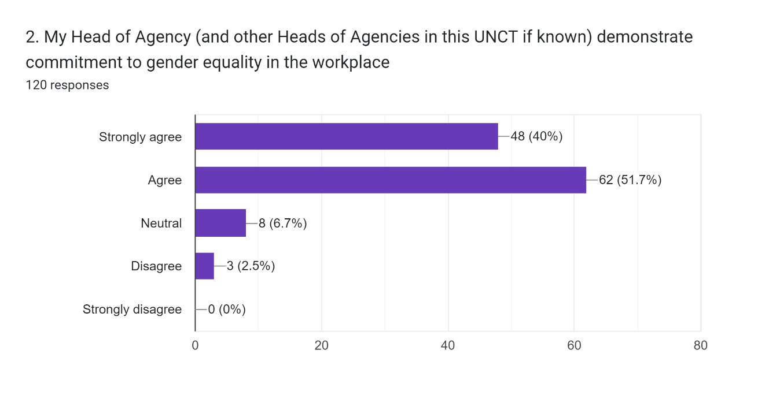  Report on the survey conducted – November 2024
4.2. ORGANIZATIONALCULTUREFULLYSUPPORTSPROMOTIONOFGENDEREQUALITYAND THE EMPOWERMENTOF WOMEN  Exceeds minimum expectation: Survey results of personnel perception of organizational environment for promotion of gender equality scored a positive rating of over 80 percent | Survey results of personnel perception of organizational environment for promotion of gender equality scored a positive rating of over 80%. The survey was conducted during the period of 5-12 November 2024 with120 staff members took part in it providing their feedback  Report on the survey conducted – November 2024  Responses spreadsheet – November 2024
6.1: Adequate Resources for Gender Mainstreaming are Allocated and Tracked  - Approaches minimum requirements and meets TWO of the following: c) The UNCT has met the common global financial target for UNCT allocations to GEWE. d) The sub-outputs coded UNCT-GEM 1,2 or 3 provide a ‘Gender Marker Narrative’ which accurately justifies the UNCT-GEM code selected. e) The Gender Theme Group (or equivalent) has completed a quality assurance review of UNCT-GEM coding during the drafting of the Joint Work Plan aligned with the GTG Standards and Procedures. | - To be reviewed once the UNINFO report is finalized  - Suboutputs coded UNCT GEM 1,2 or 3 provide gender marker narrative – not done  E. The Gender Theme Group (or equivalent) will undertake a quality assurance review of UNCT-GEM coding during the drafting of the Joint Work Plan in accordance with the GTG Standards and Procedures.

